1. Write a program that takes a number as input and prints its multiplication table upto 10.

Test Data:  
Input a number: 8  
Expected Output :  
8 x 1 = 8  
8 x 2 = 16  
8 x 3 = 24  
...  
8 x 10 = 80

SOLUTION: <https://github.com/MuhammadNaeemAkhtar/RUST/tree/master/multiplication-table>

1. Write a program that takes three numbers as input to calculate and print the average of the numbers.

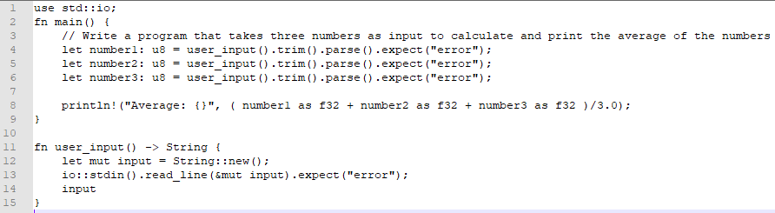

1. Write a program to print the area and perimeter of a rectangle.

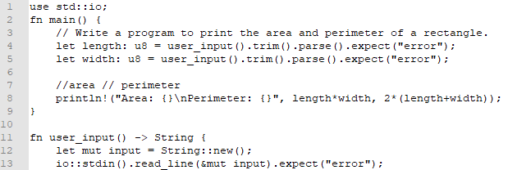

1. Write a program to swap two variables.

Solution: <https://github.com/MuhammadNaeemAkhtar/RUST/tree/master/swap-numbers>

1. Write a program and compute the sum of the digits of an integer.    
   Input Data:  
   Input an integer: 25  
   Expected Output

The sum of the digits is: 7

Solution: <https://github.com/MuhammadNaeemAkhtar/RUST/tree/master/integer-digits-sum>

1. Write a program to print the prime numbers from 1 to 99. Prints one number per line.   
   Sample Output:

1

3

5

7

9

11

....

Solution: <https://github.com/MuhammadNaeemAkhtar/RUST/tree/master/prime-numbers>

1. Write a program to accept a number and check the number is even or not. Prints 1 if the number is even or 0 if the number is odd.    
   Sample Output:

Input a number: 20

1

Solution: <https://github.com/MuhammadNaeemAkhtar/RUST/tree/master/check-even-odd>

1. Write a program to print numbers between 1 to 100 which are divisible by 3, 5 and by both.   
   Sample Output:

Divided by 3:

3, 6, 9, 12, 15, 18, 21, 24, 27, 30, 33, 36, 39, 42, 45, 48, 51, 54, 57

, 60, 63, 66, 69, 72, 75, 78, 81, 84, 87, 90, 93, 96, 99,

Divided by 5:

5, 10, 15, 20, 25, 30, 35, 40, 45, 50, 55, 60, 65, 70, 75, 80, 85, 90,

95,

Divided by 3 & 5:

15, 30, 45, 60, 75, 90,

Solution: <https://github.com/MuhammadNaeemAkhtar/RUST/tree/master/numbers-divisible-by-3-5>

1. Write a program to calculate the sum of two integers and return true if the sum is equal to a third integer.    
   Sample Output:

Input the first number : 5

Input the second number: 10

Input the third number : 15

The result is: true

Solution: <https://github.com/MuhammadNaeemAkhtar/RUST/tree/master/integer-sum-equals-integer>

1. Write a program that accepts three integers from the user and return true if two or more of them (integers ) have the same rightmost digit. The integers are non-negative.    
   Sample Output:

Input the first number : 5

Input the second number: 10

Input the third number : 15

The result is: true

Solution: <https://github.com/MuhammadNaeemAkhtar/RUST/tree/master/right-most-digit-check>

1. Write a function called city_country() that takes in the name of a city and its country. The function should return a string formatted like this: "Santiago, Chile" Call your function with at least three city-country pairs, and print the values that are returned.

Sample Output:

Fasialabad, Pakistan

Turin, Italy

Recife, Brazil

1. Write a function called make_shirt() that accepts a size and the text of a message that should be printed on the shirt. The function should print a sentence summarizing the size of the shirt and the message printed on it. Call the function to make two T-shirts.

Sample Output:

Printed "I love Pakistan" on shirt of size 27

Printed "I love Pakistan" on shirt of size 27

1. Make a function to find factorials of given number

Sample Output:

Enter number:5

Factorial of 5 is: 120

1. function to find Faboocii series till given Number

Sample Output:

Enter Number: 10

0 1 1 2 3 5 8 13 21 34

1. Make a function, that takes a vector as parameter, return a vector of square of each elements in the vector and finally prints both vectors.

Vector 1: [2, 3, 4, 5, 6]

Vector square: [4, 9, 16, 25, 36]

1. Write a program to get the larger value between first and last element of an array of integers.

Original Array: [20, 30, 40]

Larger value between first and last element: 40

1. Write a program to swap the first and last elements of a vector.

Original Vector: [20, 30, 40]

New Vector after swaping the first and last elements: [40, 30, 20]

1. Write a program to find the largest element between first, last, and middle values from an array of integers.(Odd Length)

Original Array: [20, 30, 40, 50, 67]

Largest element between first, last, and middle values: 67

1. Write a program to multiply corresponding elements of two arrays of integers.

Array1: [1, 3, -5, 4]

Array2: [1, 4, -5, -2]

Result: 1 12 25 -8

1. Write a program to check whether an given integer is a power of 4 or not.

Given num = 64, return true.

Given num = 6, return false.

110